
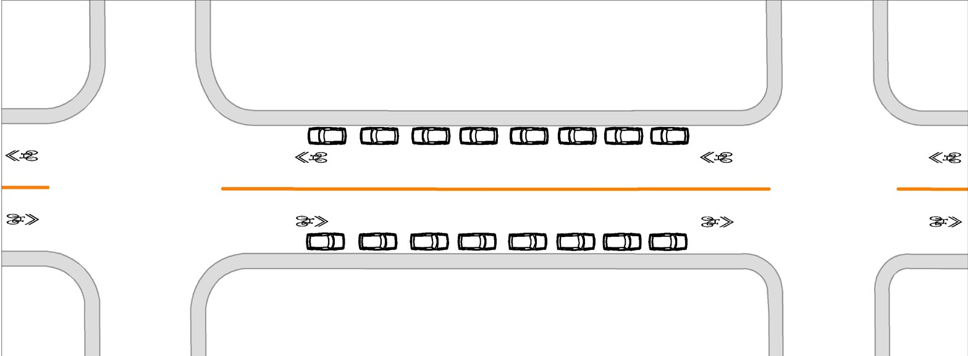
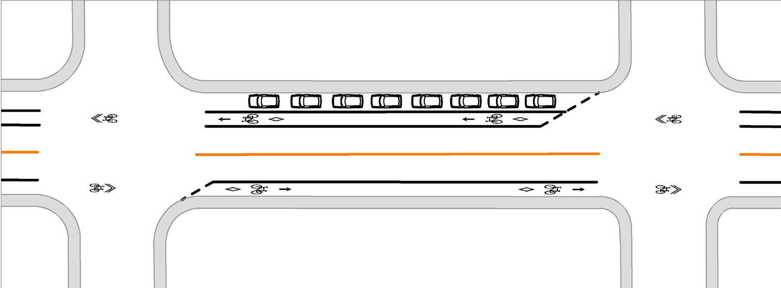
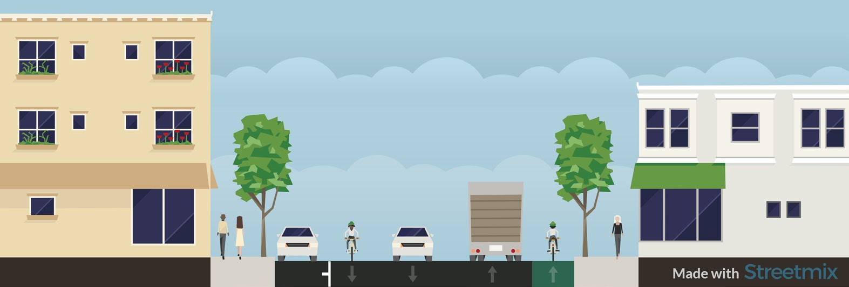

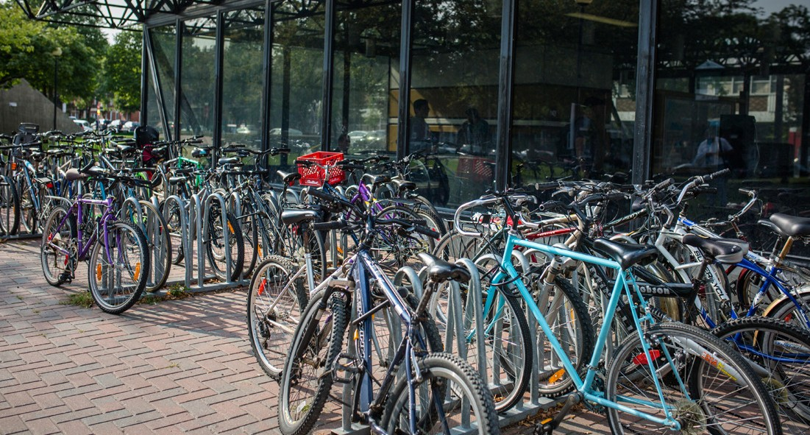
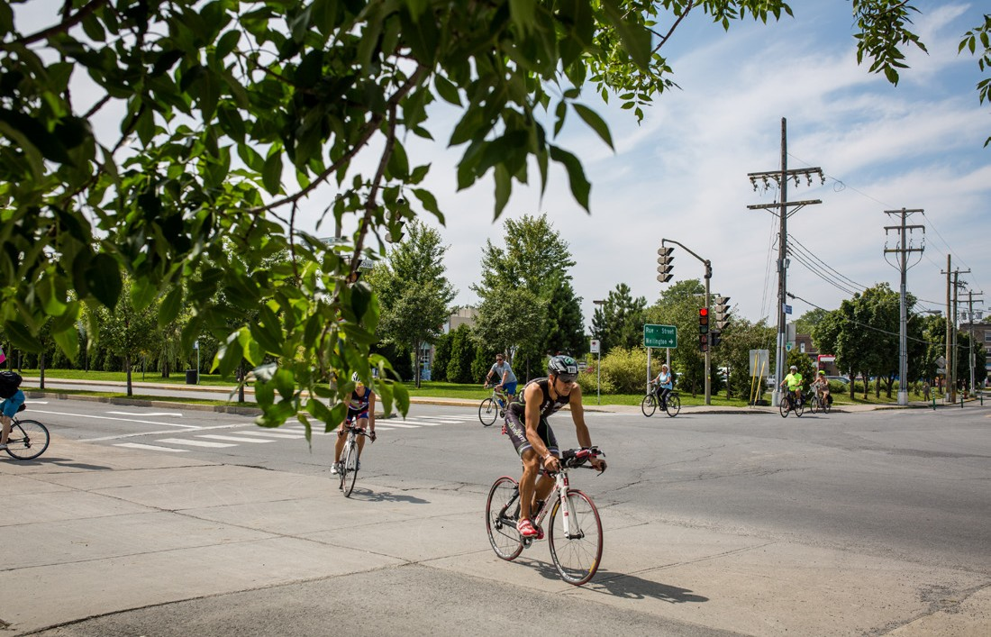
EN AVANT
Verdun
PILOT PROJECT
Rue de Verdun
BICYCLE LANES
QUESTIONS OR COMMENTS
Office of the Mayor
and Councillors of Verdun 514 765-7010
elusverdun@ville.montreal.qc.ca
EVENING PUBLIC INFORMATION MEETING:
May 9, 2019, 6:30 p.m.
Verdun Borough Hall
4555 rue de Verdun, Council room
This pamphlet is printed on FSC® certified paper and is made from 100% post-consumer recycled fibre.

Configuration of rue de Verdun from May to October

Bicycle lanes: May - October

Existing bicycle path: present designated roadway and from November to April

COMPENSATION MEASURES
Aware of the issues related to removing on-street parking spaces, the Borough has planned measures to compensate for the loss of these spaces.
Commercial zone: Short-term parking zones will be reserved during the day in the area surrounding the cross streets.
Residential zone: The Borough has reduced the requirements for
on-street parking reserved for residents for creating zones with a permit sticker. To obtain one, please call 311.
To ensure more comfort and safety for everyone using rue de Verdun, in accordance with Ville de Montréal’s Vision Zero campaign against fatal traffic accidents and serious injuries
Starting this summer, the Borough would like to try out adding two one- way bicycle lanes on rue de Verdun, a central artery in the Borough, as part of the ongoing implementation of its Local Mobility Plan.
•
On average, every year, two accidents with injuries involving cyclists are reported to the police on rue de Verdun. Setting up bicycle lanes considerably reduces accident risks.
To set up these bike lanes, parking spaces will have to be removed on the even-numbered side of the street.
The pilot project will run for two extended summer seasons, from May to October 2019 and May to October 2020.
To focus on an active lifestyle, healthy living habits and sustainable mobility
•
51% of Montréal’s population is overweight and one in three youngsters is now overweight.
By setting up bike lanes, cycling trips can be increased and made safer, thereby encouraging active travel at all ages.
Between these two seasons, parking will again be available on the even- numbered side of the street.
•
OBJECTIVES OF THE PILOT PROJECT
To upgrade the bicycle path on
rue de Verdun to meet the standards of the Ministère des Transports
du Québec
- The present designated roadway no longer meets road safety standards. More than 3,000 cars travel along rue de Verdun in each direction every day, therefore requiring separate bicycle infrastructures.
DID YOU KNOW?
The Verdun station is one of the most popular stations among cyclists using the metro system. The installation of bicycle lanes will make it possible to increase cyclists’ safety between the metro station and their homes.

